**W 03 Assignment: Introduction to the Whitewater Rafting Website**

Yuma Hanane, WDD130

1. My Logo

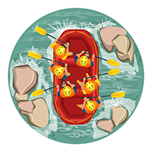

1. My colors:

primary-color: #37345B

secondary-color: #CB701B

accent1-color: #DFD45A

accent2-color: #9BF9F9

1. My fonts:

heading-font: ‘DM Serif Text’

text-font: ‘Open Sans’

1. Link to my color palette: <https://coolors.co/9bf9f9-dfd45a-cb701b-37345b>